FIRE WEATHER INDEX PREDICTOR
( FWI Predictor – A Machine Learning Model to Predict Fire Weather Index)



INFOSYS SPRINGBOARD VIRTUAL INTERNSHIP PROGRAM

SUBMITTED BY-
DOLLY KUMARI VERMA

Project Statement:
Wildfires pose a significant threat to ecosystems, human life, and property. The Fire Weather Index (FWI) is a crucial tool used by meteorological and environmental agencies worldwide to estimate wildfire potential. This project aims to build a machine learning model that predicts FWI based on real-time environmental data, enabling proactive wildfire risk management. The model is trained using Ridge Regression, deployed via a Flask web application, and supports early warning systems for wildfire hazards.

Expected Outcomes:
1.A predictive ML model trained using Ridge Regression to forecast FWL.
2.A preprocessing pipeline using Standard Scaler for normalization.
3.A Flask-based web app where users can input environmental values and get. FWI predictions.
4.A system that can help forest departments, emergency planners, and climate re-searchers make data-driven decisions.

Modules to be Implemented
1. Data Collection
2. Data Exploration (EDA) and Data Preprocessing
3. Feature Engineering and Scaling
4. Model Training using Ridge Regression
5. Evaluation and Optimization
6. Deployment via Flask App
7. Presentation and Documentation

Tools and Technologies Used:
Springboard is presenting
Programming Language: Python 3.13
Libraries: NumPy, Pandas, Scikit-learn, Matplotlib, Seaborn
Milestone 1: Data Collection and Preprocessing
Module 1: Data Collection
I began my project by downloading the FWI Dataset.csv file from Kaggle. This dataset contains several important environmental features that are commonly used to analyze and predict fire weather conditions. These features include Temperature, Relative Humidity (RH), Wind Speed (Ws), Rain, and a set of fire danger rating components such as FFMC, DMC, DC, ISI, BUI, and FWI. During my initial exploration, I also added a new column called Region to help categorize and better understand the data.
When I first opened the dataset, I noticed that it contained a few unwanted, empty, and inconsistent rows. These rows could later cause errors while performing analysis, cleaning, or training machine learning models. To avoid such issues, I manually went through the dataset using Excel and removed all the blank rows and irrelevant entries. This step helped me make sure that the dataset was well-organized, clean, and ready for further processing in Python.
This initial cleaning process was important because it ensured that the data I was working with was reliable. With the cleaned dataset prepared, I was able to smoothly load it into a Pandas DataFrame for the next steps of data exploration and preprocessing.
1.LOAD THE DATASET:
import pandas as pd
import numpy as np
import matplotlib.pyplot as plt
import seaborn as sns
from sklearn.preprocessing import LabelEncoder
df = pd.read_csv('FWI Dataset.csv')
print("Loaded the dataset into a Pandas Dataframe")
df
OUTPUT :
Loaded the dataset into a Pandas Dataframe

2.DATATYPES:
#print("data types of the dataset")
#display(df.dtypes)
df.columns = df.columns.str.strip()
for col in df.select_dtypes(include='object').columns:
df[col] = df[col].astype(str).str.strip()
df['DC'] = pd.to_numeric(df['DC'], errors='coerce')
df['FWI'] = pd.to_numeric(df['FWI'], errors='coerce')
df['Classes'] = df['Classes'].map({'not fire': 0, 'fire': 1})
df['Region'] = df['Region'].map({'Bejaia': 0,'Sidi-Bel Abbes': 1})
df.dtypes
OUTPUT:
day int64
month int64
year int64
Temperature int64
RH int64
Ws int64
Rain float64
FFMC float64
DMC float64
DC float64
ISI float64
BUI float64
FWI float64
Classes float64
Region int64
dtype: object
3.DATASET INFO
display(df.head())
display(df.tail())
print("Shape of dataset:")
display(df.shape)
print("Info of dataset:")
display(df.info())
OUTPUT:
Info of dataset:
<class 'pandas.core.frame.DataFrame'>
RangeIndex: 244 entries, 0 to 243
Data columns (total 15 columns):
# Column Non-Null Count Dtype
--- ------ -------------- -----
0 day 244 non-null int64
1 month 244 non-null int64
2 year 244 non-null int64
3 Temperature 244 non-null int64
4 RH 244 non-null int64
5 Ws 244 non-null int64
6 Rain 244 non-null float64
7 FFMC 244 non-null float64
8 DMC 244 non-null float64
9 DC 244 non-null object
10 ISI 244 non-null float64
11 BUI 244 non-null float64
12 FWI 244 non-null object
13 Classes 243 non-null object
14 Region 244 non-null object
dtypes: float64(5), int64(6), object(4)
memory usage: 28.7+ KB

4.MISSING VALUES:
print("Missing values:")
display(df.isnull().sum())
df.isnull().sum()/df.shape[0]*1 #percentage of missing values
df.columns = df.columns.str.strip()
df['Classes']=df['Classes'].fillna(df['Classes'].mode()[0])
display(df.isnull().sum())
OUTOUT:
day 0.000000
month 0.000000
year 0.000000
Temperature 0.000000
RH 0.000000
Ws 0.000000
Rain 0.000000
FFMC 0.000000
DMC 0.000000
DC 0.000000
ISI 0.000000
BUI 0.000000
FWI 0.000000
Classes 0.004098
Region 0.000000
dtype: float64

5.DUPLICATES
print("finding duplicates:")
df.duplicated().sum
print("garbage values")
for i in df.select_dtypes(include="object").columns:
print(df[i].value_counts())
print("***"*10)
OUTPUT:
finding duplicates:
garbage values
DC
8 5
7.6 4
7.8 4
8.3 4
7.5 4
..
28.1 1
36.1 1
44.5 1
7.9 1
16.5 1
Name: count, Length: 198, dtype: int64
******************************
FWI
0.4 12
0.8 10
0.1 9
0 9
0.5 9
..
19.3 1
17.5 1
15.4 1
15.2 1
6.5 1
Name: count, Length: 126, dtype: int64
******************************
Classes
fire 132
not fire 101
fire 4
fire 2
not fire 2
not fire 1
not fire 1
not fire 1
Name: count, dtype: int64
******************************
Region
Bejaia 122
Sidi-Bel Abbes 122
Name: count, dtype: int64
******************************
MODULE2
BOXPLOT-TO IDENTIFY OUTLIER DETECTION:
##BOXPLOT-TO IDENTIFY OUTLIER DETECTION
#BOX PER COLUMN
for i in df.select_dtypes(include="number").columns:
sns.boxplot(data=df,x=i)
plt.show()
#BOX IN SINGLE PLOT
plt.figure(figsize=(12,6))
df.boxplot(rot=45)
plt.title("BOXPLOT TO IDENTIFY OUTLIERS")
plt.show()
OUTPUT:
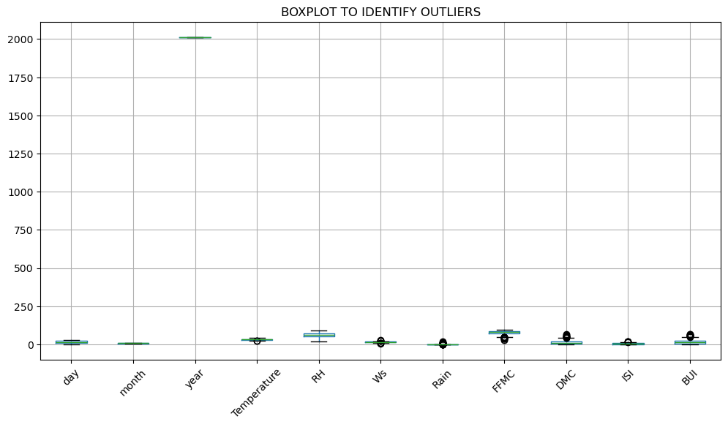
# ---- Identify numeric columns ----
numeric_features = df.select_dtypes(include=['int64', 'float64']).columns
# ---- Custom function to catch outliers using IQR ----
def find_iqr_outliers(frame, feature):
q1_val = frame[feature].quantile(0.25)
q3_val = frame[feature].quantile(0.75)
iqr_range = q3_val - q1_val
lower_cut = q1_val - (1.5 * iqr_range)
upper_cut = q3_val + (1.5 * iqr_range)
detected = frame[(frame[feature] < lower_cut) | (frame[feature] >
upper_cut)]
return detected
# ---- Loop through numeric columns and show results ----
for feature in numeric_features:
outlier_rows = find_iqr_outliers(df, feature)
print(f"{feature} ® Outlier Count: {len(outlier_rows)}")
OUTPUT:
day → Outlier Count: 0
month → Outlier Count: 0
year → Outlier Count: 0
Temperature → Outlier Count: 2
RH → Outlier Count: 0
Ws → Outlier Count: 8
Rain → Outlier Count: 35
FFMC → Outlier Count: 16
DMC → Outlier Count: 12
ISI → Outlier Count: 4
BUI → Outlier Count: 12

###EDA####
df.describe()
df.describe(include="object")
print("histogram to understand the distribution")
for i in df.select_dtypes(include="number").columns:
sns.histplot(data=df,x=i)
plt.show()
import warnings
warnings.filterwarnings("ignore")
plt.figure(figsize=(12,6))
for col in numeric_cols:
sns.kdeplot(df[col], label=col)
plt.title("Density Plot for Numeric Features")
plt.legend()
plt.show()
OUTPUT:
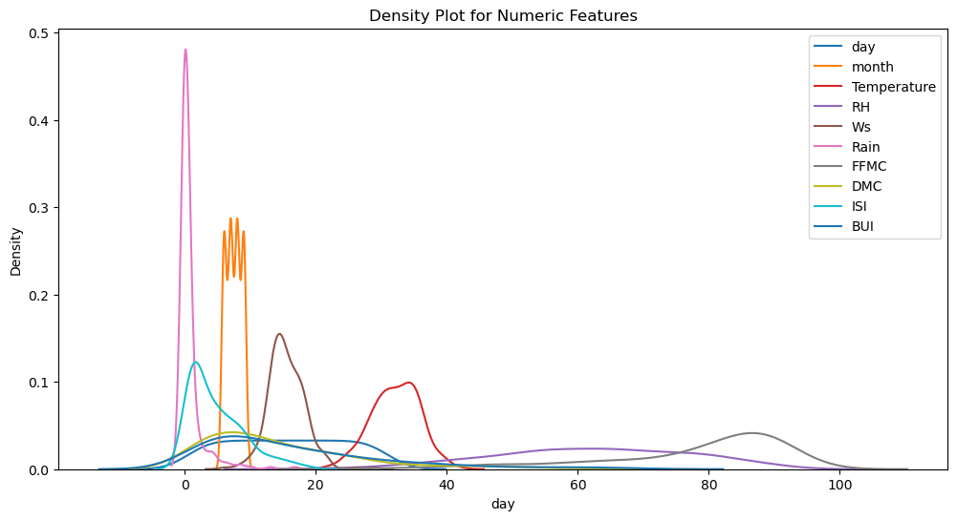
###EXPLORED RELATIONSHIPS
##SCATTERPLOT to understand the relationship
sns.pairplot(df.select_dtypes(include='number'))
plt.show()
df.select_dtypes(include="number").columns
for i in ['day', 'month', 'year', 'RH', 'Ws', 'Rain', 'FFMC',
'DMC', 'ISI', 'BUI']:
sns.scatterplot(data=df,x=i,y='Temperature')
plt.show()
OUTPUT:
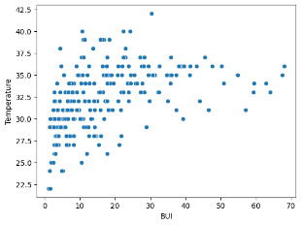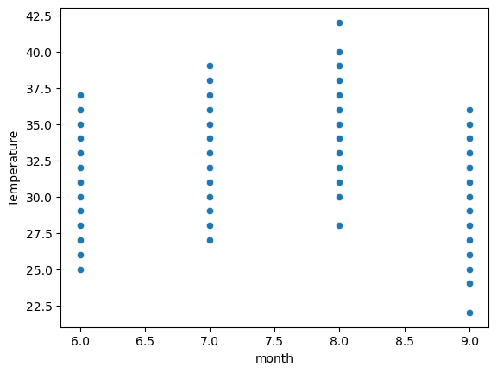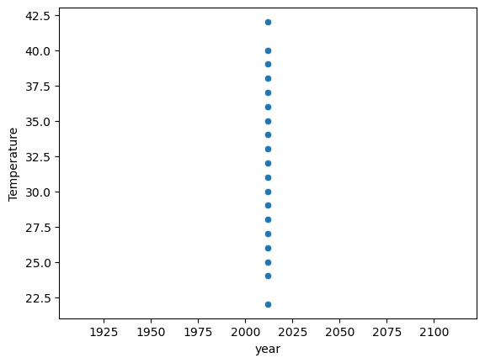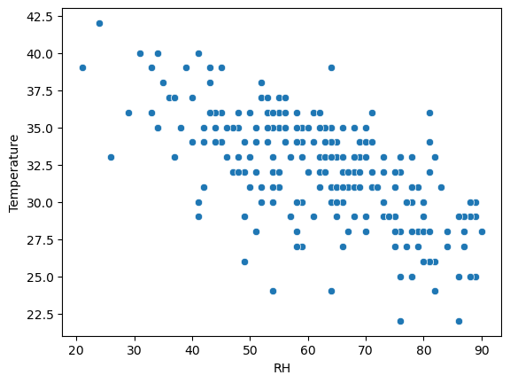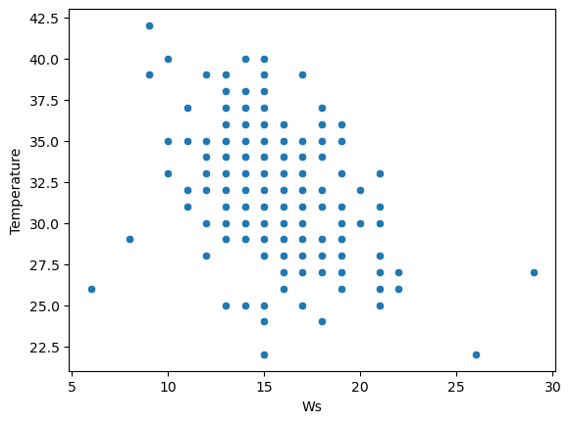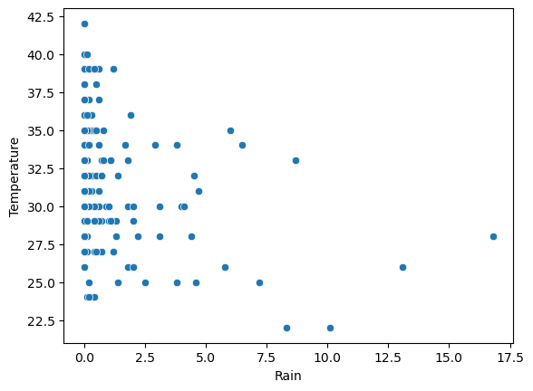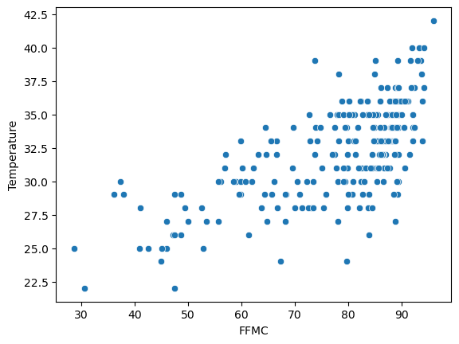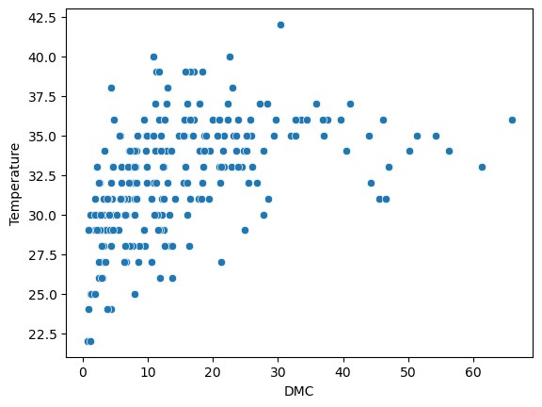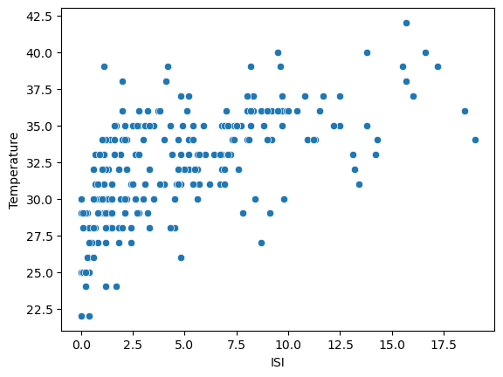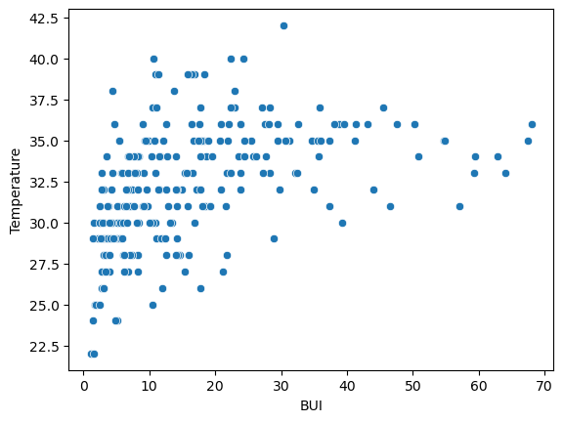
:
#CORRELATION WITH HEATMAP
s=df.select_dtypes(include="number").corr()
sns.heatmap(s)
OUTPUT:
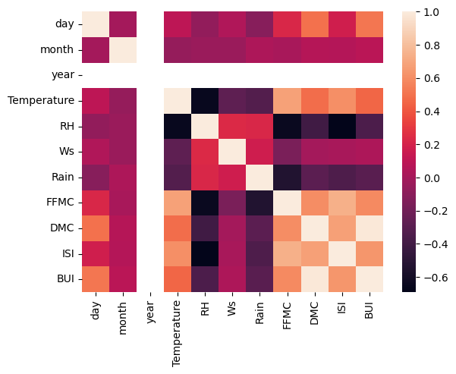
#CORRELATION MATRIX
num_features = df.select_dtypes(include=['float64', 'int64']).columns
corr_map = df[num_features].corr()
plt.figure(figsize=(12, 8))
sns.heatmap(corr_map, annot=True, cmap="coolwarm", fmt=".2f")
plt.title("Correlation Heatmap of Numerical Features")
plt.show()
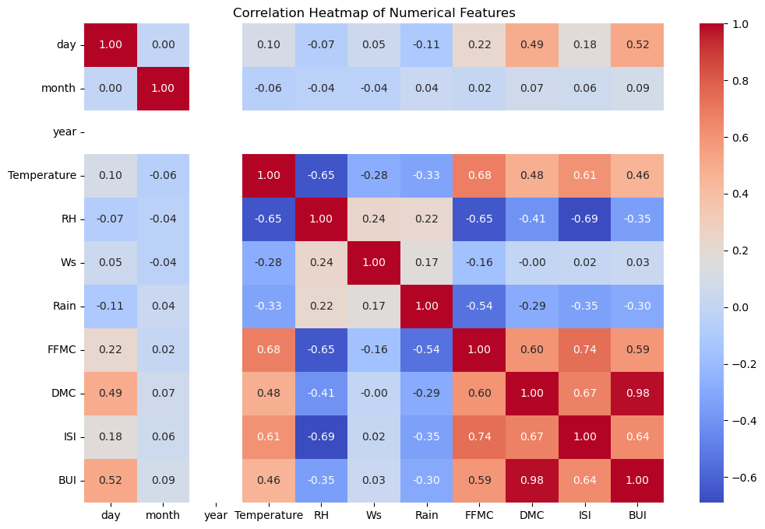
# Encoding categorical variable
df.columns = df.columns.str.strip()
print("Unique values in Region column:", df["Region"].unique())
encoder = LabelEncoder()
df["Region_Encoded"]= encoder.fit_transform(df["Region"])
df[["Region", "Region_Encoded"]].head()
OUTPUT:
 | Region | Region_Encoded
0 | Bejaia | 0
1 | Bejaia | 0
2 | Bejaia | 0
3 | Bejaia | 0
4 | Bejaia | 0

#Mapping regions
print("\nRegion Mapping:")
region_mapping = dict(zip(encoder.classes_,
encoder.transform(encoder.classes_)))
print(region_mapping)
df["Region_Encoded"] = df["Region_Encoded"].astype("category")
print(df[["Region", "Region_Encoded"]].dtypes)
OUTPUT:
Region Mapping:
{'Bejaia': np.int64(0), 'Sidi-Bel Abbes': np.int64(1)}
Region object
Region_Encoded category
dtype: object
#Saved the cleaned dataset
df.to_csv("FWI_Cleaned.csv", index=False)

######## MODULE-3 #########
## Feature Engineering and Scaling ##
print(df.columns)
print(df['FWI'].dtype)
print(corr.columns)
OUTPUT:
Index(['day', 'month', 'year', 'Temperature', 'RH', 'Ws', 'Rain', 'FFMC','DMC', 'DC', 'ISI', 'BUI', 'FWI', 'Classes', 'Region'],
dtype='object')
object
Index(['Temperature', 'RH', 'Ws', 'Rain', 'FFMC', 'DMC', 'ISI', 'BUI'], dtype='object')
##COORELATION
df.columns = df.columns.str.strip()
df.drop(columns=['day','month','year','Region','Classes'], inplace=True, errors='ignore')
plt.figure(figsize=(10, 8))
corr = df.select_dtypes(include='number').corr()
sns.heatmap(corr, annot=True, cmap='coolwarm')
plt.title("Correlation Matrix")
plt.show()
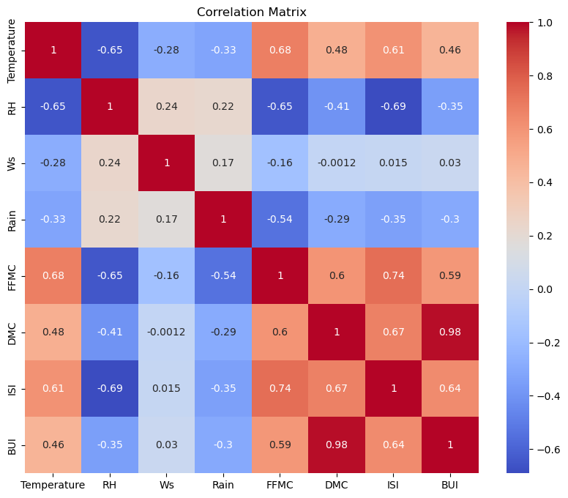
######## MODULE-3 #########
## Feature Engineering, Scaling & Correlation ##
# Show columns for debugging
print("Available columns:", df.columns.tolist())
# Drop unwanted columns safely
df.drop(columns=['day', 'month', 'year', 'Region', 'Classes'], inplace=True, errors="ignore")
# Correlation matrix (numeric only)
corr = df.select_dtypes(include=[np.number]).corr()
# Check if 'FWI' exists before using it
if 'FWI' in corr.columns:
corr_target = corr['FWI'].abs()
selected_features = list(corr_target[corr_target >= 0.30].index)
print("Selected features:", selected_features)
else:
print("'FWI' column not found in DataFrame. Available numeric columns:", corr.columns.tolist())
selected_features = []
OUTPUT:
Available columns: ['Temperature', 'RH', 'Ws', 'Rain', 'FFMC', 'DMC', 'DC', 'ISI', 'BUI', 'FWI']
'FWI' column not found in DataFrame.
Available numeric columns: ['Temperature', 'RH', 'Ws', 'Rain', 'FFMC', 'DMC', 'ISI', 'BUI']
###.PICKLE
from sklearn.model_selection import train_test_split
from sklearn.preprocessing import StandardScaler
import pickle
if 'Ws' in df.columns and 'Ws' not in selected_features:
selected_features.append('Ws')
if 'FWI' in selected_features:
selected_features.remove('FWI')
print("Selected Features:", selected_features)
##Split into X and y
X = df[selected_features].copy()
y = df['FWI'].copy()
##Train-test split
X_train, X_test, y_train, y_test = train_test_split(X, y,test_size=0.2,random_state=42)
print("Shapes — X_train:", X_train.shape, "X_test:", X_test.shape)
print("Training set shape:", X_train.shape, y_train.shape)
print("Testing set shape:", X_test.shape, y_test.shape)
OUTPUT:
Selected Features: ['Ws']
Shapes — X_train: (195, 1) X_test: (49, 1)
Training set shape: (195, 1) (195,)
Testing set shape: (49, 1) (49,)
###
caler = StandardScaler()
scaler.fit(X_train)
X_train_scaled = scaler.transform(X_train)
X_test_scaled = scaler.transform(X_test)
#Save the scaler as a .pkl file
with open('scaler.pkl', 'wb') as f:
pickle.dump(scaler, f)
print("Scaler saved successfully as scaler.pkl")
OUTPUT:
Scaler saved successfully as scaler.pkl

#### MODULE4 ###
import pickle
from sklearn.linear_model import Ridge
from sklearn.metrics import mean_squared_error, mean_absolute_error
alphas = [0.01, 0.1, 1, 10, 100]
results = []
print(df.isna().sum())
from sklearn.impute import SimpleImputer
imputer = SimpleImputer(strategy='mean')
X_train_scaled = imputer.fit_transform(X_train_scaled)
X_test_scaled = imputer.transform(X_test_scaled)
OUTPUT:
Temperature 0
RH 0
Ws 0
Rain 0
FFMC 0
DMC 0
DC 0
ISI 0
BUI 0
FWI 0
dtype: int64
######## MODULE-4 #########
### Ridge Regression with Target Cleaning
from sklearn.preprocessing import StandardScaler
from sklearn.model_selection import train_test_split
# Step 1: Convert all columns to numeric
df = df.apply(pd.to_numeric, errors="coerce")
# Step 2: Drop rows where target 'FWI' is NaN
df = df.dropna(subset=["FWI"])
# Step 3: Separate features and target
X = df.drop(columns=["FWI"], errors="ignore")
y = df["FWI"]
# Step 4: Train/test split
X_train, X_test, y_train, y_test = train_test_split(X, y, test_size=0.2, random_state=42)
# Step 5: Impute missing values in features
imputer = SimpleImputer(strategy="mean")
X_train_imputed = imputer.fit_transform(X_train)
X_test_imputed = imputer.transform(X_test)

# Step 6: Scale features
scaler = StandardScaler()
X_train_scaled = scaler.fit_transform(X_train_imputed)
X_test_scaled = scaler.transform(X_test_imputed)
# Step 7: Train Ridge models
alphas = [0.01, 0.1, 1, 10, 100]
results = []
for a in alphas:
model = Ridge(alpha=a, random_state=42)
model.fit(X_train_scaled, y_train.values.ravel()) # ensure target is 1D
y_pred = model.predict(X_test_scaled)
rmse = np.sqrt(mean_squared_error(y_test.values.ravel(), y_pred))
mae = mean_absolute_error(y_test.values.ravel(), y_pred)
results.append([a, rmse, mae])
# Step 8: Show results
results_df = pd.DataFrame(results, columns=["Alpha", "RMSE", "MAE"])
print(results_df)
OUTPUT:
Alpha RMSE MAE
0 0.01 0.600443 0.426188
1 0.10 0.638673 0.440237
2 1.00 0.751348 0.476902
3 10.00 0.989129 0.677105
4 100.00 1.928386 1.488433

###3Tuned the alpha parameter to balance bias-variance tradeoff
from sklearn.linear_model import RidgeCV
best_alpha = ridge_cv.alpha_
y_pred = ridge_cv.predict(X_test_scaled)
rmse = np.sqrt(mean_squared_error(y_test, y_pred))
r2 = r2_score(y_test, y_pred)
print("Best Alpha:", best_alpha)
print("RMSE:", rmse)
print("R² Score:", r2)
OUTPUT:
Best Alpha: 1.0
RMSE: 0.7513475825728835
R² Score: 0.981374048463563

##Step 8: Evaluate training & validation performance
y_train_pred = ridge_cv.predict(X_train_scaled)
y_test_pred = ridge_cv.predict(X_test_scaled)
train_rmse = np.sqrt(mean_squared_error(y_train, y_train_pred))
test_rmse = np.sqrt(mean_squared_error(y_test, y_test_pred))
train_r2 = r2_score(y_train, y_train_pred)
test_r2 = r2_score(y_test, y_test_pred)
print("Best Alpha:", ridge_cv.alpha_)
print("Training RMSE:", train_rmse, "R²:", train_r2)
print("Validation RMSE:", test_rmse, "R²:", test_r2)
#Save trained model
with open("ridge.pkl", "wb") as f:pickle.dump(ridge_cv, f)
#Document training process
doc = { "Model": "Ridge Regression","Alpha candidates": alphas,"Best Alpha": ridge_cv.alpha_,"Training RMSE": train_rmse,"Training R²": train_r2,"Validation RMSE": test_rmse,"Validation R²": test_r2,"Preprocessing": {"Imputer": "SimpleImputer(strategy='mean')","Scaler": "StandardScaler()"},"Random State": 42}
print("\nTraining Documentation:\n", pd.Series(doc))
OUTPUT:
Best Alpha: 1.0
Training RMSE: 1.2815126950299665 R²: 0.9729313264255482
Validation RMSE: 0.7513475825728835 R²: 0.981374048463563
Training Documentation:
Model Ridge Regression
Alpha candidates [0.01, 0.1, 1, 10, 100]
Best Alpha 1.0
Training RMSE 1.281513
Training R² 0.972931
Validation RMSE 0.751348
Validation R² 0.981374
Preprocessing {'Imputer': 'SimpleImputer(strategy='mean')', ...
Random State 42

